NASSAU COUNTY LEGISLATURE
15th TERM MEETING AGENDA
MINORITY AFFAIRS COMMITTEE

FEBRUARY 5, 2024 1:00 PM

Scott Strauss – Chairman
Samantha Goetz – Vice Chairwoman
Rose Marie Walker
Michael Giangregorio
Carrié Solages – Ranking
Debra Mulé
Seth I. Koslow

Michael C. Pulitzer, Clerk of the Legislature

Scan the QR code to submit written public comment,
which will be incorporated into the record of this meeting.
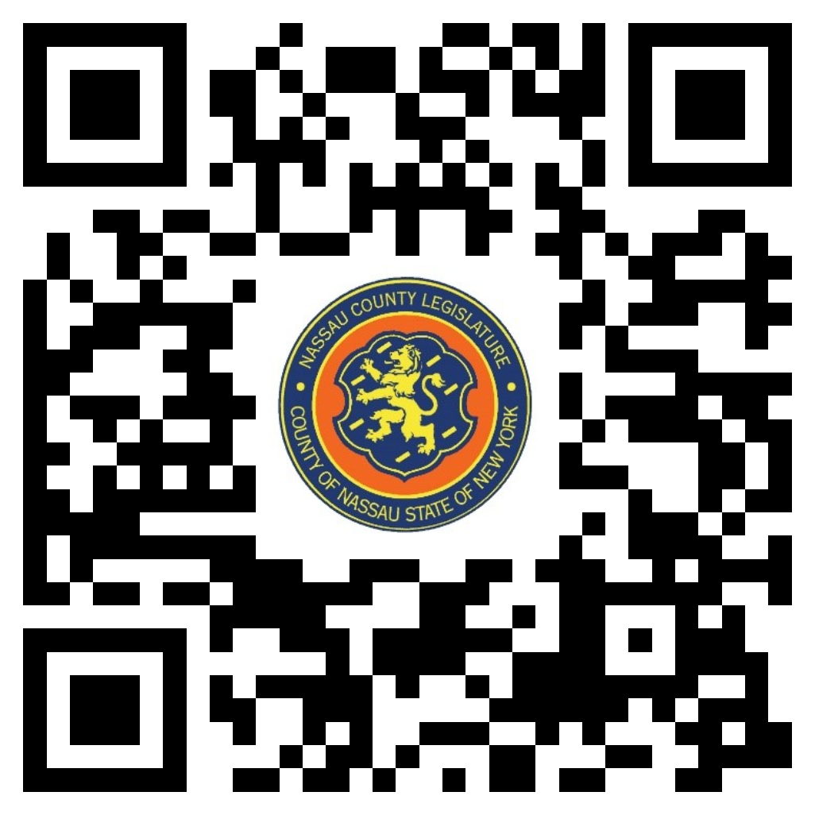

THERE ARE NO ITEMS ON THIS COMMITTEE AT THIS TIME

