NASSAU COUNTY LEGISLATURE
15th TERM MEETING AGENDA
TOWNS, VILLAGES & CITIES
COMMITTEE
FEBRUARY 5, 2024 1:00 PM

Mazi Melesa Pilip – Chairwoman
C. William Gaylor III – Vice Chairman
Samantha Goetz
Scott Strauss
Debra Mulé – Ranking
Seth I. Koslow
Scott M. Davis

Michael C. Pulitzer, Clerk of the Legislature

Scan the QR code to submit written public comment,
which will be incorporated into the record of this meeting.
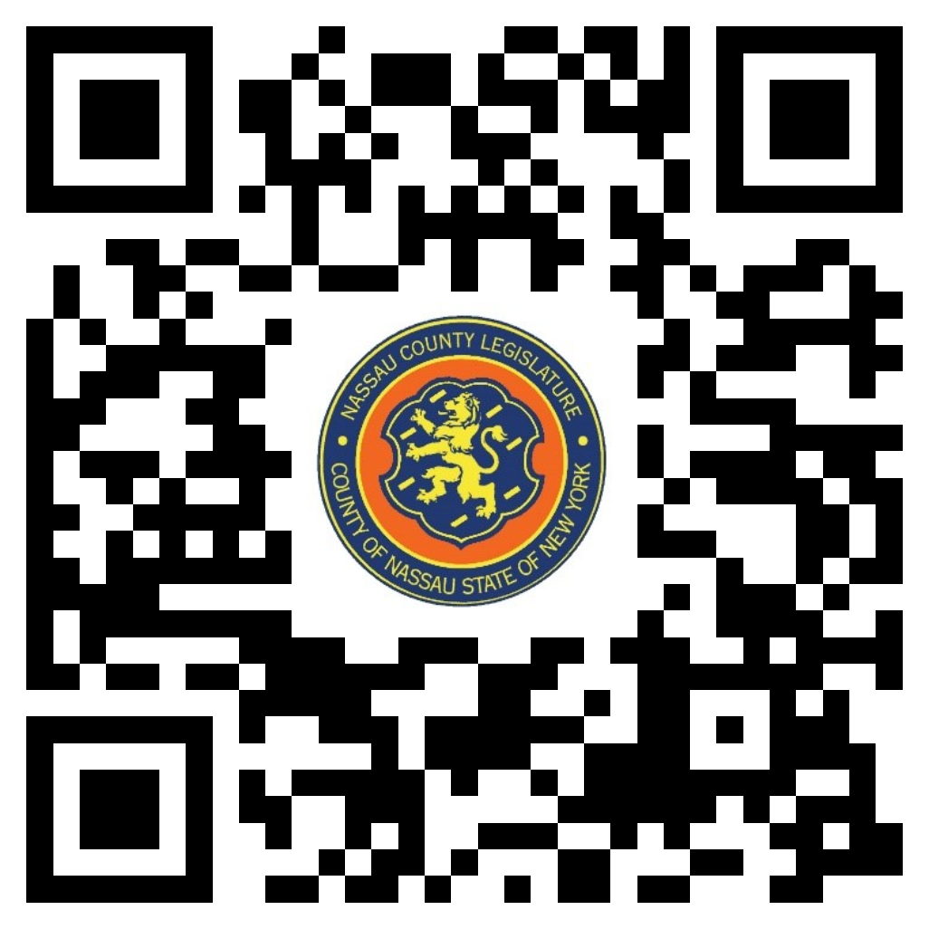

THERE ARE NO ITEMS ON THIS COMMITTEE AT THIS TIME

