JOHN E. IMHOF, PhD
COMMISSIONER
EDWARD P. MANGANO
COUNTY EXECUTIVE

Nassau County
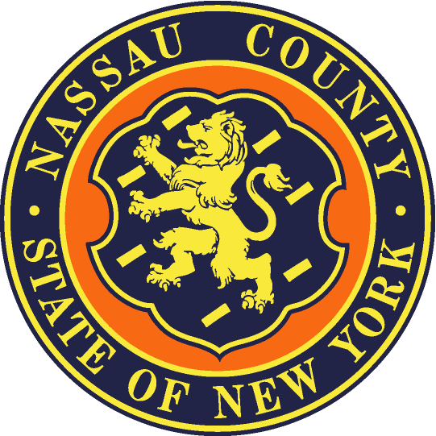
Department of Social Services
60 CHARLES LINDBERGH BLVD., SuiTE 160
UNIONDALE, New York 11553-3686
NASSAU COUNTY DSS FACILITY HOMELESS REFERRAL FORM
Date Click here to enter a date. Medical Facility Name Click here to enter text.
Name and contact # of Referral Source Click here to enter text.
PATIENT NAME Click here to enter text. DOB Click here to enter a date.
SS# IF KNOWN Click here to enter text.
MA/TA CIN IF ACTIVE in any county Click here to enter text.
Does patient have legal status in the United States? ☐ Yes ☐ No
If patient has a case manager what is the case manager’s name, agency, contact # if known:
Click here to enter text.
Admission date Click here to enter a date. Proposed discharge date Click here to enter a date.
ADDRESS PRIOR TO ADMISSION* Click here to enter text.
Can patient return to this address? If not, explain Click here to enter text.
(If not Nassau County, does patient wish to return to county of last residence? If so, please refer to the local DSS for that county. See http://ocfs.ny.gov/main/localdss.asp for contact information). * If referring patient for temporary housing placement, potential housing resources in the form of friends, family, neighbors must be explored even if only available on a temporary basis.

INCOME/RESOURCES* (Indicate source, amount and if verified and available) Patients referred must meet NYS Temporary Assistance eligibility requirements.
Click here to enter text.
Indicate if the client has any physical limitations (please indicate if patient requires first floor placement due to limitations): Click here to enter text.
DOES PATIENT REQUIRE SKILLED NURSING OR AIDE SERVICES TO RESIDE SAFELY IN THE COMMUNITY? Click here to enter text. (If so, please explore if placement in a rehab, SNF or Assisted Living residence would better meet the patient’s needs.)
Complete Reverse Side of Referral Form
NC DSS FACILITY HOMELESS REFERRAL FORM (REV 4-15)
-2-

DOES PATIENT HAVE AN ACTIVE SUBSTANCE ABUSE/ALCOHOL AND/OR MENTAL HEALTH CONDITION? (specify) Click here to enter text. (If yes, is patient prescribed medication or in an out-patient treatment program for condition?) ☐ Y ☐ N

IF EXHIBITING SIGNS OF MH Dx, HAVE THEY BEEN ASSESSED AND CLEARED FOR PLACEMENT IN A SHELTER? ☐ Y ☐ N

HAS PATIENT BEEN PRESCRIBED MEDICATION FOR A SERIOUS CONDITION/ILLNESS?
☐ Yes ☐ No (If so, please ensure they have been discharged with necessary medication and/or prescriptions. Please note if medication requires refrigeration.) Click here to enter text.
Is patient a veteran? ☐Yes ☐ No

E-MAIL REFERRAL TO:

Tressa.Davis@hhsnassaucountyny.us
Lisa.Amato@hhsnassaucountyny.us
Marjorie.Krohn@hhsnassaucountyny.us
JamieLee.Essig@hhsnassaucountyny.us
John.Imhof@hhsnassaucountyny.us

FAX REFERRAL TO:
Tressa Davis
Assistant Director of TA New Applications
Nassau County Department of Social Services
60 Charles Lindbergh Blvd Ste 160
Uniondale, NY 11553
(516) 227-8012
(516) 227-8744 (fax)

