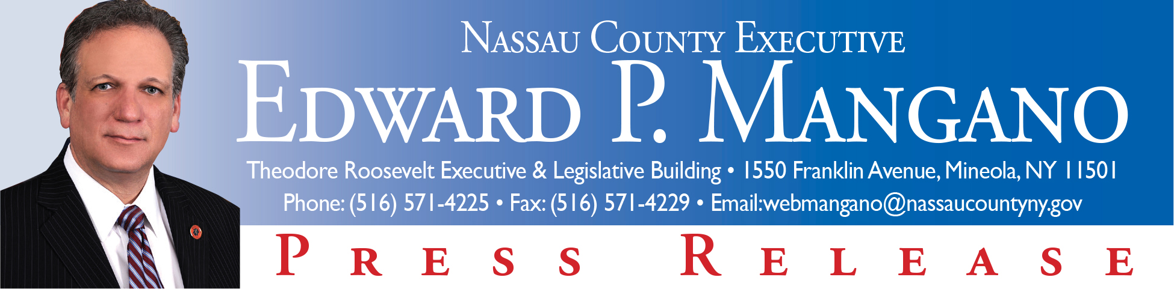

For Immediate Release: December 22, 2014
Contact: Katie Grilli-Robles, Press Secretary (516) 571-4225

Mangano Announces Kwanzaa Celebration
Mineola, NY - Nassau County Executive Edward P. Mangano announced today that Nassau County's 5th Annual Kwanzaa Celebration will take place on Monday, December 29th at 12:00 p.m. at Roosevelt Field Mall, North Court which is by Dick's Sporting Goods and Bloomingdale's Furniture.

“I invite all residents to take some time from their busy schedules to enjoy this wonderful holiday celebration,” said County Executive Mangano.

Kwanzaa has emerged as a significant celebration during which residents can both commemorate and reflect upon Africa roots, as well as the awe-inspiring impact it has had on the American experience. Kwanzaa is a family-friendly celebration involving a candle lighting including a festive, educational, and inspirational program that beautifully reflects the principles of UNITY.

For more information, please contact Ray Thomas at (516) 227-9675 or Shelley Brazley at (516) 572-2244.

###

