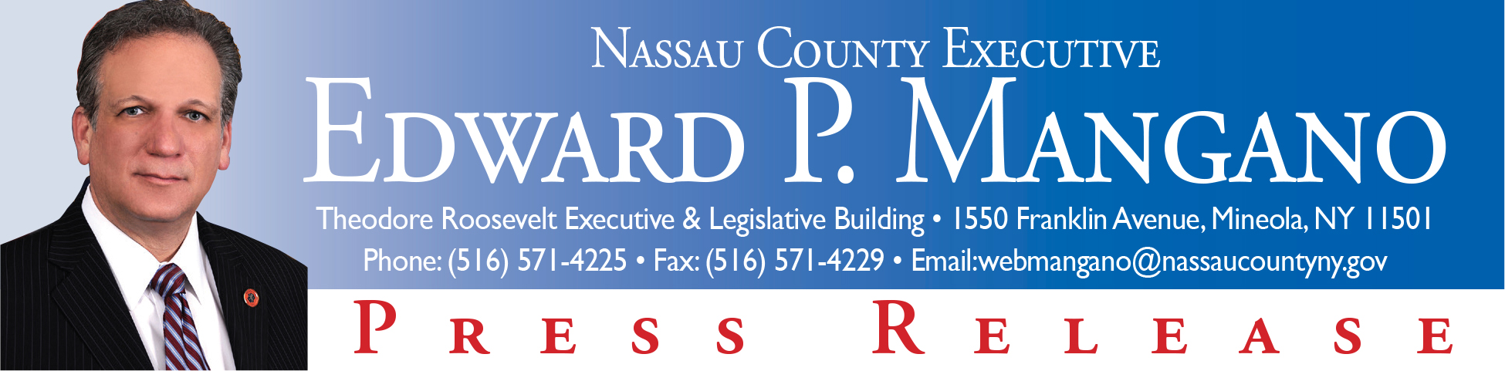

For Immediate Release: September 18, 2014
Contact: Katie Grilli-Robles, Press Secretary (516) 571-4225

Mangano: Celebrating Hispanic Heritage Month In Nassau County

Arts, Music, Dance & Folklore to provide joy and pride to residents

Mineola, NY - Nassau County Executive Edward P. Mangano announced a week-long series of events in celebration of Hispanic Heritage Month, which began on Monday September 15th with a celebration of Chile’s independence, followed by an illumination of the dome at the Theodore Roosevelt Executive and Legislative Building in Mineola to honor all Central American countries.

The Consulate General of Chile joined Monday night’s celebration, co-hosted by County Executive Mangano and Nassau’s Coordinating Agency for Spanish Americans (CASA) and Nassau County’s Office of Minority Affairs. Spanish Heritage Month beginning on September 15th and continuing through October 15th will consist of a variety of events to celebrate the history, heritage and culture of the entire Hispanic Community.

“Throughout this month, we will join the nation in celebrating the culture, history and contributions of Hispanic and Latino Americans,” County Executive Mangano said. “We will pay tribute to their efforts in strengthening and nourishing our country’s history, commerce, cultural identity, and resolve.”

As County Executive Mangano does every year at this time, he will also recognize the heritage of Mexico this month, during the anniversary of its independence. On Thursday, September 18th, the celebration continues with an exhibit at the Theodore Roosevelt Executive and Legislative building, showcasing the works of Salvadoran artist, Lisbeth.

Probably the most anticipated event of Heritage month and one that shows great pride and patriotism for the entire Hispanic community is the free celebration paying tribute to all Hispanic cultures and customs, Latin Night. Latin Night (Noche Latina), which will take place on Sunday September 21st, starting at 2pm. The event is sponsored by Canon USA, Briarcliff Collage, ICC Mortgages and The NY Cosmos. In addition, County Executive Mangano will honor individual members of the Hispanic community for their integral role in enriching our culture, sports and sciences, at 7pm on Sunday, September 21st at Lakeside Theatre in Eisenhower Park during Latin Night. The celebration will also include a folkloric journey through the dance and music of Banda Paz, of El Salvador, as well as Salsa and other live music. The Rhythmology dance group as well as the Cosmo Soccer team Girls will have a performance.

“Nassau County’s Noche Latina gives us the opportunity to celebtrate with our residents, and highlight the diversity of Latin American cultures,” County Executive Mangano said. “Latino Americans are among the fastest growing populations in Nassau.”
Some of the upcoming Hispanic month events include, on September 18th from 6p.m.-8p.m. there will be an exhibit of the works of Salvadoran artist, Lisbeth, which will be held at the County Executive & Legislative building, this date also marks the anniversary of Chile’s independence. Following that event on September 21st from 2 p.m. - 9 p.m. Latin Night (Noche Lataina) will take place at Lakeside Theatre in Eisenhower Park. On September 30th in conjunction with the Argentinian Cultural Center and the Consulate General of Argentina, County Executive Mangano will host an evening full of Music & Art of Argentina from 6p.m. to 8p.m., at the Executive & Legislative building, featuring renowned pianist Rosa Antonelli and artist Daniel Bottero.

In addition to those events, There will be a celebration on October 12th entitled Dia de la Raza also known as Day of the Races, which is similar to Columbus for the U.S, that will celebrate the colonization of Latin America.

For more information please contact County Executive Mangano’s office at (516) 571 3261 or at hflores@nassaucountyny.gov

###

