NASSAU COUNTY LEGISLATURE
15th TERM MEETING AGENDA

HEALTH AND SOCIAL SERVICES COMMITTEE ADDENDUM
JANUARY 8, 2024 1:00 PM
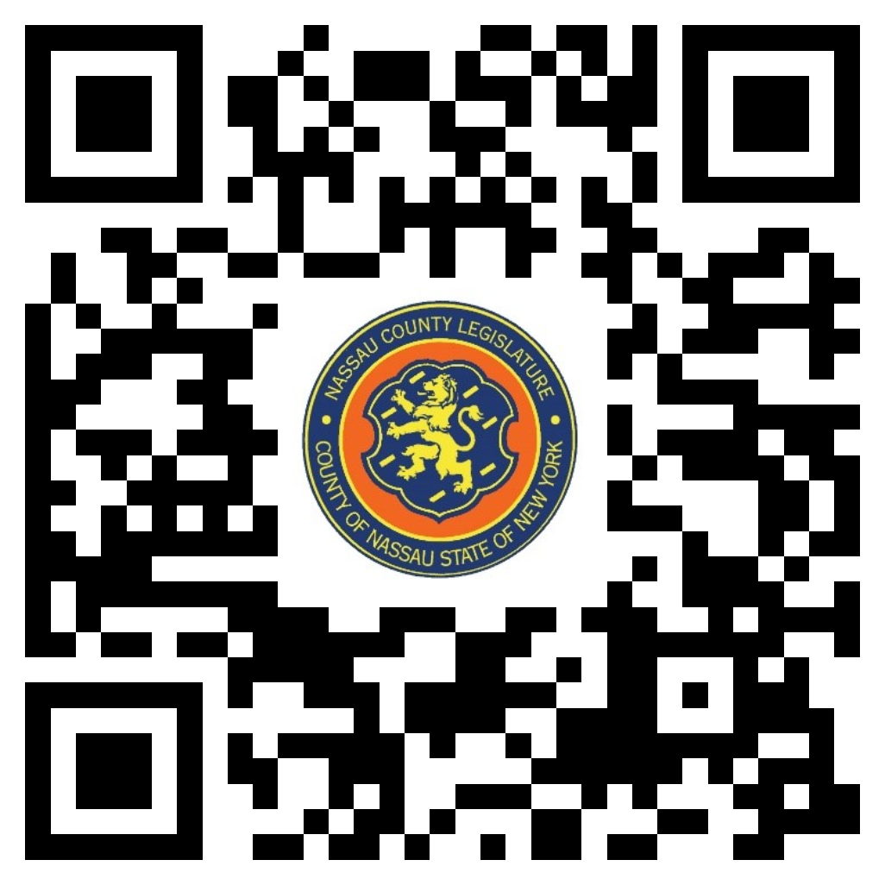

Scan the QR code to submit written public comment,
which will be incorporated into the record of this meeting.

Clerk Item  No. | Proposed By | Assigned To | Summary
9-24 | OMB | H, F, R | ORDINANCE NO. – 2024  AN ORDINANCE SUPPLEMENTAL TO AN APPROPRIATION ORDINANCE IN CONNECTION WITH THE HEALTH DEPARTMENT. 9-24(OMB)

